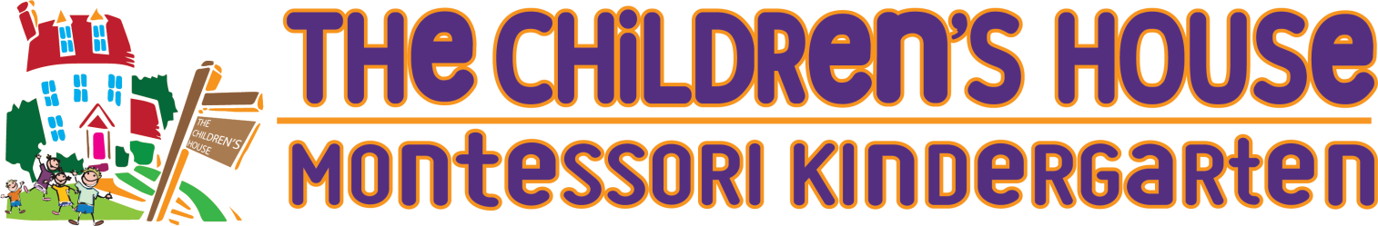

SAFETY AND PRECAUTION PROCEDURE HANDOUT

SEPTEMBER 2020

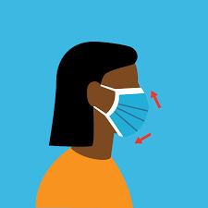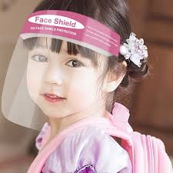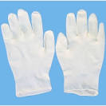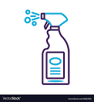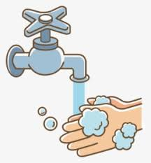

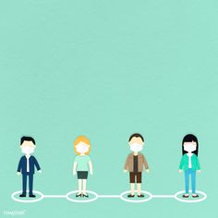

The Ministry of Education has given permission for kindergartens and private schools in Bahrain to reopen, as per their individual term schedules for the academic year 2020 - 2021. As we come close to the time of opening the kindergarten on the 6th of September 2020, we would like to reassure our students, staff, and families of the safety precautions to be implemented in school.
- Following the direction of The Ministry of Education, all staff must download and use the BeAware App. Parents with a mobile device are also strongly encouraged to use the App.

- The following guidelines are designed to keep students, parents and staff safe whilst we operate school during this pandemic.
You/your child must only come to school if:
- You/your child’s temperature is below 37.5ºC;
- You and your family members are well and not symptomatic;
- You and your family members have not been in contact with anyone who has tested positive or is showing symptom of Covid-19 within the past 14 days.

- We request the parents to drop and pick up the students at the main gate of the school. School timings: Morning drop off at 8:00am, Afternoon pick up at 12:00pm.
You must observe the 2m social distancing rule at all times, when queueing please observe the markers on the floor. If there is no markers, then leave 2m gap.

- A staff member will be bringing in the children to wash/sanitize their hands first before entering the classroom. Shoes and bags will be sprayed with disinfectant on arrival.

- We will be checking the temperatures of both the students and staff by the main gate before entering the school. Anyone with a temperature reading of over 37.5 degrees or higher will not be allowed to enter.

- All visitors will undergo temperature screening and be asked to complete a short, health declaration survey on arrival at school. Visitors to the school will be by appointment only.

- Floor markers will be placed 2 meters apart in entrance hallway to ensure social distancing.

- Staff will be required to wear a face mask and/or Face shield/Visors. We will be requesting the parents to provide their children face shields/visors when they send their children to school. Parents/guardians are requested to wear masks at the drop off and pick up times at the school gate.

- Domestic staff will wear masks/gloves and face shields at all times. Gloves will be changed after helping each child in the bathroom. The bathrooms will be sanitized after every use during the morning and a full sanitation takes place at the end of the school day.

- All classrooms, furniture and materials in the classroom will be sanitized at the end of every day.

- Classrooms have been configured to accommodate 12 students as a maximum at any one time. All students will sit at separate desks. We create a space of 2m between each student’s desk.

- We will also be creating stickers with their names with pictures for the children to help them understand where they are designated to sit in the classroom at their desk. There will be stickers on the floors of the classrooms for the children to stand on to keep distance when standing in a line.

- The children will choose activities that they are interested in, and will work at their designated desk.

- We will be assisting the children to wash their hands every 30 minutes, before they move to a different area of Montessori Learning as well as when they have their snacks and go to the toilet. Hand sanitizer and hand washing facilities are available to encourage frequent usage.

- All students must bring their own pencils, colored pencils, sharpener, safety scissors, glue stick, eraser (etc.) … in a pencil case, clearly labelled with their name.

- All students must bring their own food and will eat their snack at their designated table. Their snack box should be labelled with their name.

- Students and staff must arrive at School each day with a freshly filled reusable water bottle.

- During circle time, we will be assigning the children to sit on their designated tables whereas the teacher will be in the front of the room at her table to conduct a circle time.

- During play time, we will be allocating half the classroom, one group with a teacher to play outdoors while the other group with the assistant teacher to play indoors.
- With regards to spare clothes, we will be asking the parents to provide the spare clothes and place them in a disposable bag along with a name tag of the child.

- Children will be monitored throughout the morning for any signs of fever and/or coughing or general signs of being unwell. If a child becomes unwell during the morning, then a designated staff member will take the child to an isolation room and remain with him/her until a parent comes to collect him/her. The school will then continue contact with the parent to determine if any signs of Covid-19 virus is suspected.
From September 2020, we anticipate that children will be physical returning to school, a hybrid of in school and Virtual learning. Any change to the model will be communicated to parents, for example if the risk level increases, the school will be closed and the virtual school model is needed.
Included with the health-declaration form will be a legal disclaimer which confirms that by choosing to send their child to school, parents may not hold the school liable in the event that their child contracts COVID-19. This does not excuse the school in any way from carrying out the rigorous health and safety precautions described in this document. Access will not be permitted for any child for whom the health declaration form has not been returned.

This year, children have been deprived of the opportunity of introduction to school during their most important formative years. This lack of social interaction and opportunity to experience hands on learning in a structured environment can impact their success in further schooling. Please be assured that we, at The Children’s House Montessori Kindergarten, will continue to do our best to ensure that our students are given the best possible schooling in order to thrive during these times.

